Table of Contents

1 Introduction 2

2 Technical Architecture 2

2.1 Folder Structure 2

2.1.1 TWF 2

2.1.2 SRC/Test/Java 2

2.1.3 JRE System Library 3

2.1.4 Maven Repository 3

2.1.5 Pictures 3

2.1.6 Target 3

2.2 Design Procedure 3

# Introduction

# Technical Architecture

## Folder Structure

### TWF

#### SRC/Main/Java

##### Config

###### Config.properties

###### Log4j.properties

##### Logs

###### (all the logs)

##### Object Repository

##### Reports

##### Test Data

###### TestCases.excel

##### Test Drivers

###### Driver.java

###### MainClass.java

##### Utility

###### ExcelHandler.java

###### TestExecutor.java

###### UtilityClass.java

### SRC/Test/Java

#### Test Actions

##### Actions1

##### Actions2

#### Test Cases

##### TC01

##### TC02

### JRE System Library

### Maven Repository

### Pictures

### Target

## Design Procedure

### Setting up Driver

* Create a configuration file in config package as [config.properties]
* Config file is used to store configuration related details such as common location path, email id. Etc. It can also be used to store global variables such as page load timeout, Test data sheet names etc.
* Details in config file is added in a key value pair format (eg. Key = Value).
* Create a Driver class in Test Driver package as [Driver.Java]. Driver class is used to setup and initialize the automation run. This class will be the parent to mostly all the other classes.
* Create a static block inside Driver.java class which will be called the first time when the class is instantiated or a static variable or method is invoked. This Block will be called before the constructor of the class.
* The static block will be used to initialize the Logging functionality so that the Logger is initialized as soon as the script runs and will be initialized only once.
* Create the log4j.properties file in config package and it will be used in the static block.
* The static block will have the below code  
  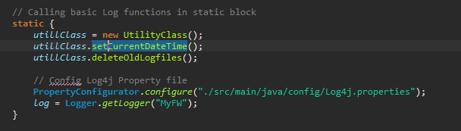
* Next create the constructor of driver class. The constructor of driver class is called every time the Class is instantiated. Constructor of driver class will be used to read the config file and hence it can be used any sub classes. Here prop variable is created as public static variable so that it can be used with the class.

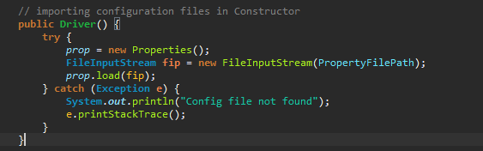

* Apart from that the Driver class will which test cases has to be ran and what data it has to use. This can be achieved by another function to read the excel sheet and trigger only those test cases which are marked to be ran. There are other ways to achieve it but this is how this framework is designed.
* Now create a MainClass.java file inside the testDriver package. This class will be the first class where the automation framework will start. Create the Main method in this class. Start the first logging into the log file. This is achievable since log is defined as a static variable in driver class
* As soon as the driver class is called it will trigger the above mentioned static block which will initialize the log properties.